August 25, 2014

The Honorable Lisa Murkowski (AK)

The Honorable Mike Crapo (ID)

The Honorable Jon Tester (MT)

The Honorable Ron Wyden (OR)

The Honorable Patty Murray (WA)

The Honorable Mike Enzi (WY)

The Honorable Mark Begich (AK)

The Honorable James Risch (ID)

The Honorable John Walsh (MT)

The Honorable Jeff Merkley (OR)

The Honorable Maria Cantwell (WA)

The Honorable John Barrasso (WY)

Dear Senators:

As the leaders of nonprofit and philanthropic networks in Alaska, Idaho, Montana, Oregon, Washington and Wyoming, we ask for your support of the ***America Gives More Act (H.R. 4719)*** that would have positive impacts on communities across our shared region. We collectively represent over 2,600nonprofits and foundations, and we believe this is a unique opportunity to make available more charitable resources that address the pressing community needs of our constituents.

The ***America Gives More Act (H.R. 4719)*** was passed with bi-partisan support in the U.S. House of Representatives in July and it now awaits passage in the U.S. Senate. The Act includes five significant tax provisions encouraging giving by foundations and individuals:

1. Permanently reinstating the IRA charitable rollover;
2. Simplifying the excise tax to 1 percent for private foundations’ investment income (thereby reducing the administrative work and enabling more giving to immediate community need);
3. Permanently reinstating the enhanced deduction for donating land conservation easements;
4. Permanently reinstating the enhanced deduction for donating food inventory; and
5. Extending the deadline for claiming charitable donations on the previous year’s tax filing through April 15.

We understand that there is a brief window between the August and September recesses to take action, and if not, the process starts over with a new Congress in January 2015.

**We urge you to request that Majority Leader Harry Reid and Minority Leader Mitch McConnell bring the *America Gives More Act (H.R. 4719)* to the Senate floor for a vote and ask for your support of H.R. 4719 as soon as the Senate reconvenes in September.**

Thank you for your commitment to the communities with our region by supporting a strong and thriving nonprofit and philanthropic sector. We both stand ready to provide additional information about why your support of the America Gives More Act would benefit the people of Alaska, Idaho, Montana, Oregon, Washington and Wyoming.

Sincerely,



Alison McCaffree, Executive Director, Washington Nonprofits

[ed@washingtonnonprofits.org](mailto:ed@washingtonnonprofits.org), 253-820-0731

*Washington Nonprofits builds a strong, collaborative network of nonprofits serving Washington communities through advocacy, education and capacity building.*

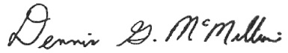

Dennis McMillan, President and CEO, The Foraker Group

[dmcmillian@forakergroup.org](mailto:dmcmillian@forakergroup.org), 907-743-1202

*The Foraker Group is dedicated to a healthy, sustainable nonprofit sector in Alaska.*

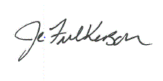

Janice Fulkerson, Executive Director, Idaho Nonprofit Center

[jfulkerson@idahononprofits.org](mailto:jfulkerson@idahononprofits.org), 208-424-2229, ext. 5

*Idaho Nonprofit Center provides resources to build strong and accountable nonprofits and a platform to rally public involvement and gain support for the nonprofit sector in Idaho.*

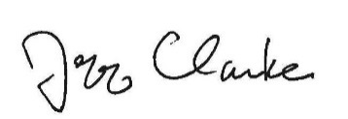

Jeff Clarke, CEO, Philanthropy Northwest

[jclarke@philanthropynw.org](mailto:jclarke@philanthropynw.org); 206-443-8431

*Philanthropy Northwest promotes, facilitates and drive collaborative action by philanthropic organizations to strengthen our communities in Alaska, Idaho, Montana, Oregon, Washington and Wyoming.*

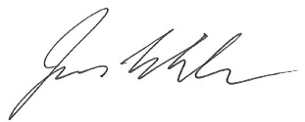

Jim White, Executive Director, Nonprofit Association of Oregon

[jwhite@nonprofitorgeon.org](mailto:jwhite@nonprofitorgeon.org), 503-239-4001, ext. 109

*Nonprofit Association of Oregon strengthens the collective voice, leadership, and capacity of nonprofits to enrich the lives of all Oregonians.*

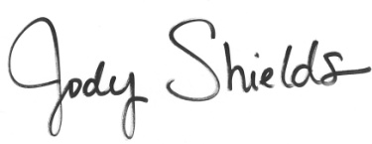

Jody Shields, Managing Director, Wyoming Nonprofit Network

[jshields@thealignteam.org](mailto:jshields@thealignteam.org), 307-772-9148

*Wyoming Nonprofit Network strengthens the leadership, skills, effectiveness and efficiency of Wyoming nonprofits; enabling them to further enrich the quality of community and personal life in Wyoming*.

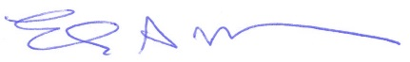

Liz Moore, Executive Director, Montana Nonprofit Association

[lmoore@mtnonprofit.org](mailto:lmoore@mtnonprofit.org), 406-449-3717

*Montana Nonprofit Association promotes a strong nonprofit sector in Montana.*